Discover which primary foods you are missing, and how to infuse joy and satisfaction into your life.
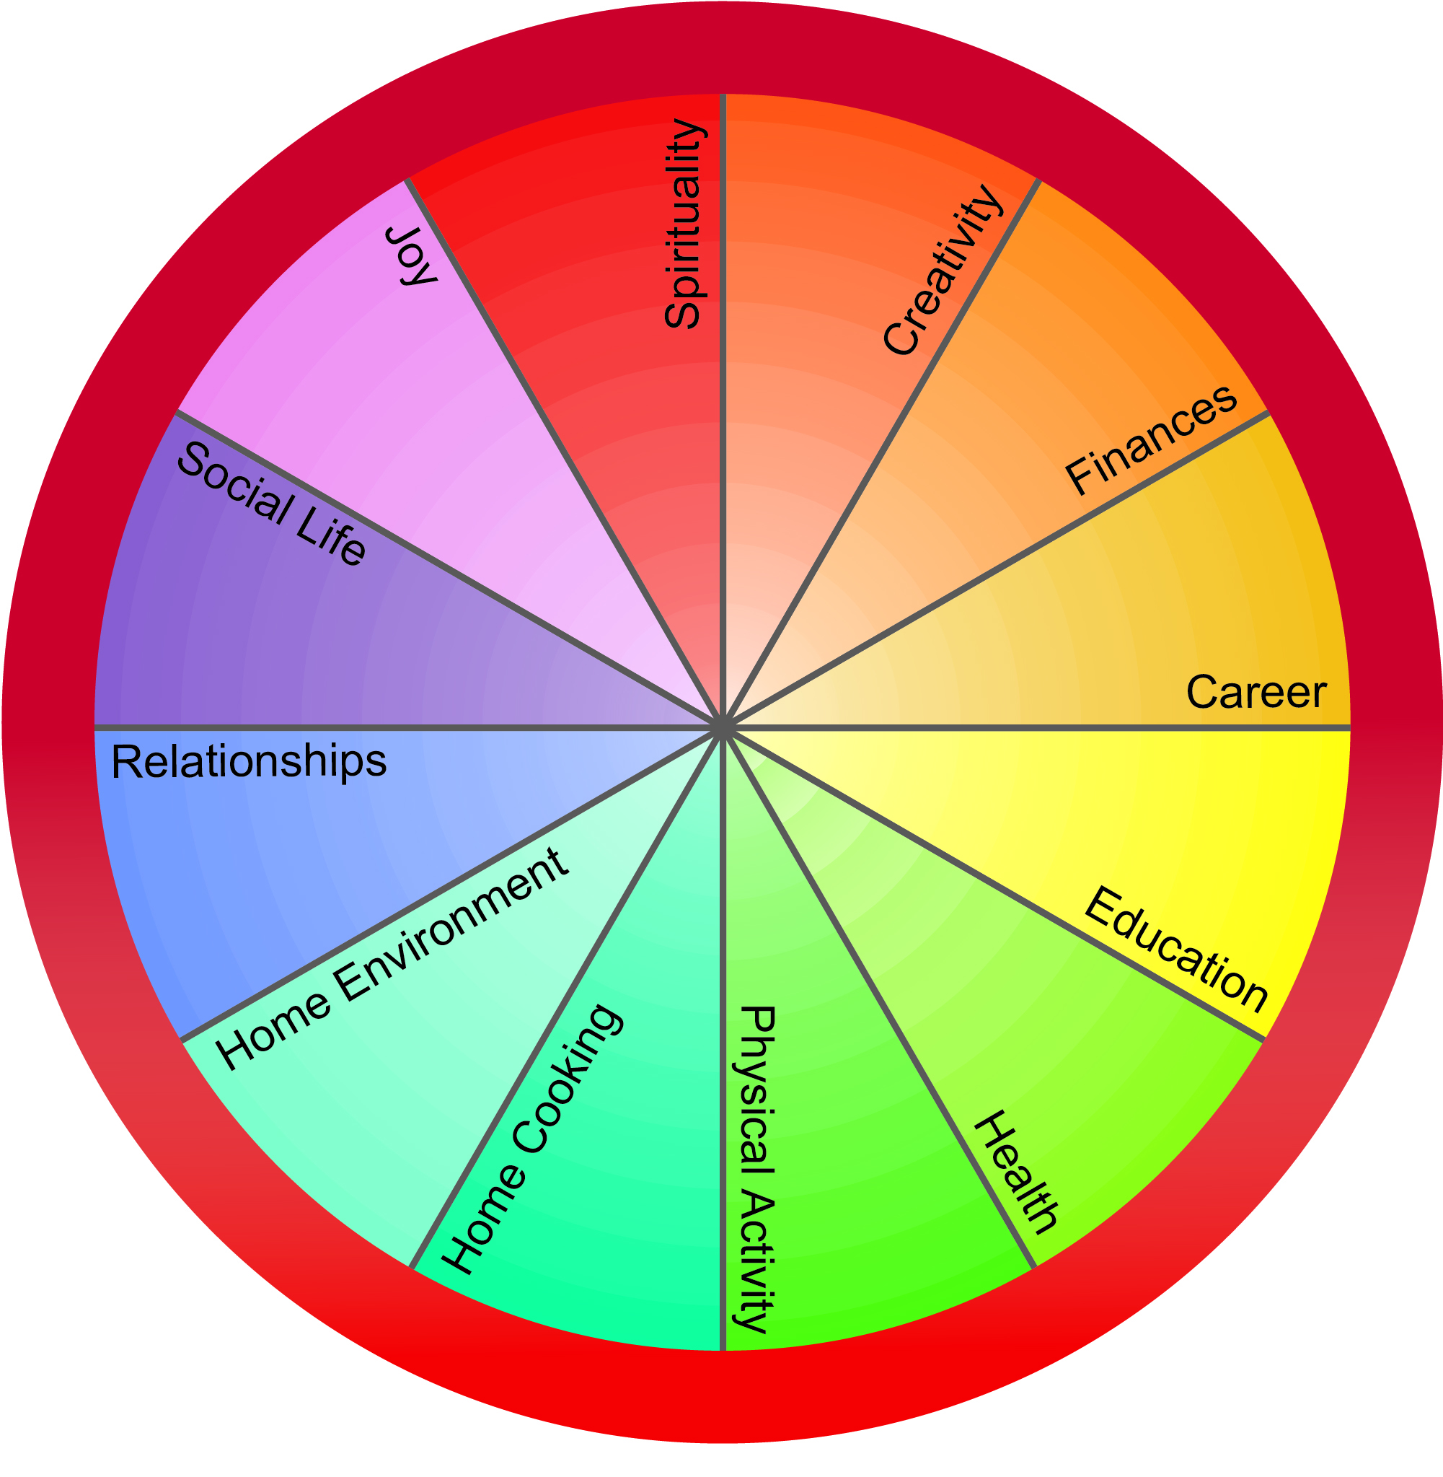
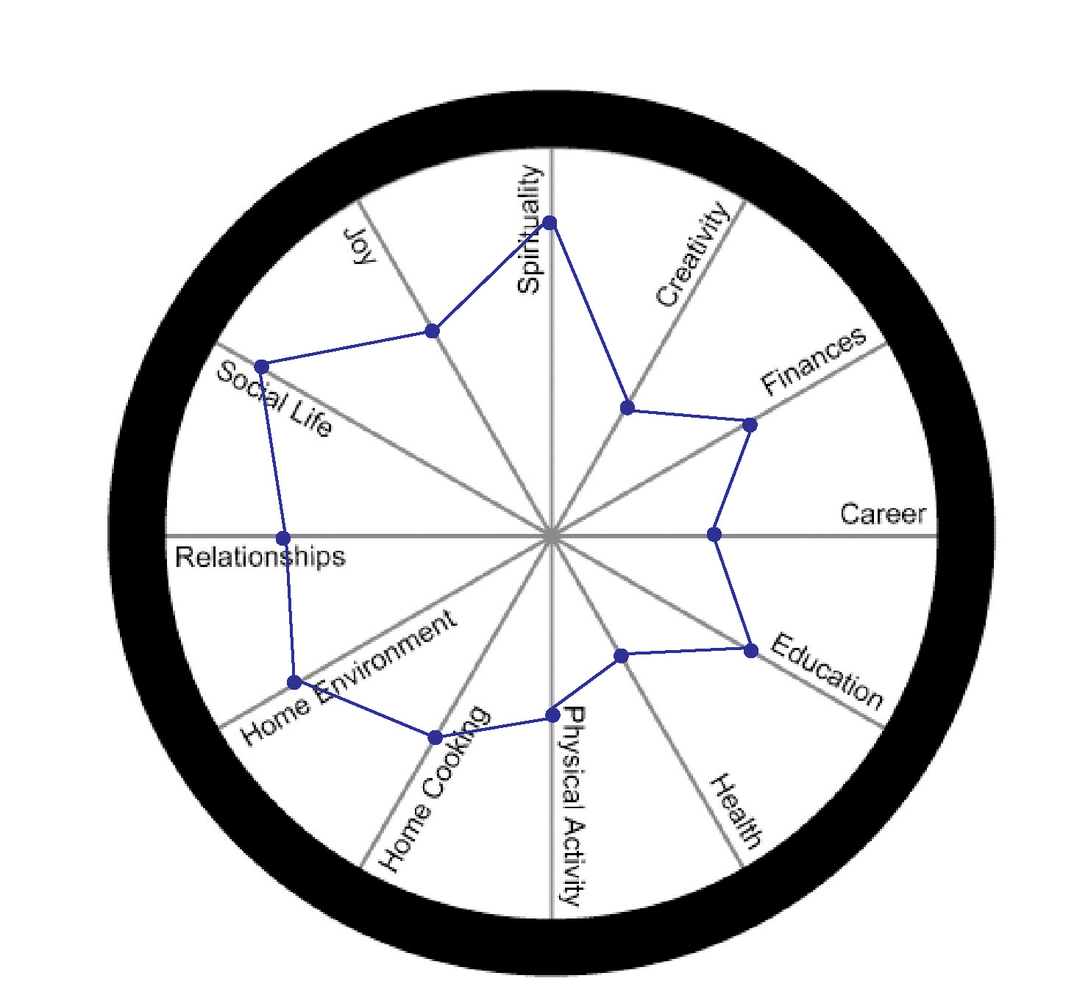
Example

What does YOUR life look like?
- Place a dot on the line in each category to indicate your level of satisfaction within each area.
Place a dot at the center of the circle to indicate dissatisfaction, or on the periphery to indicate satisfaction. Most people fall somewhere in between. (see example)
- Connect the dots to see your Circle of Life.
- Identify imbalances. Determine where to
spend more time and energy to create balance.

